Innovating Responsibility: Fostering Creative CompetenceS for Sustainable Engineering Solutions

Conference Key Areas: Diversity, equity and inclusion in our universities and in our teaching, Building the capacity and strengthening the educational competences of engineering educators
Keywords: creativity, innovation, diversity, responsibility, competences

MOTIVATION AND LEARNING OUTCOMES
In an increasingly technology-driven and complex world, STEM jobs are crucial for fostering innovation with a focus on social and environmental responsibility. However, the engineering sector is currently facing a shortage of qualified professionals. Therefore, it is crucial to adequately prepare young individuals for careers in engineering to ensure a sustainable future. To address the lack of skilled professionals, education plays a vital role in developing relevant skills that drive innovative and creative solutions (Cropley 2015; Felder 1988). Beyond intellectual capabilities, research highlights the impact of self-efficacy – the belief in one's ability to surmount challenges – on students' motivation, interest, and success in both academic and vocational pursuits. Evidence suggests (AUTHOR 2023) that individuals with a strong sense of their own competence tend to be more resilient in completing tasks and solving problems. Within STEM disciplines, creativity is widely acknowledged as a fundamental element in addressing modern demographic, technological, and societal challenges. Consequently, creativity is an essential attribute for aspiring engineers and a key determinant for career success.
In Germany, there is a significant underrepresentation of women in STEM fields, especially in engineering. Gender stereotypes and conflicts act as barriers that discourage women from pursuing careers in these fields (AUTHORS 2023).
Incorporating creative methods into teaching offers a potential avenue to reverse this trend by making STEM subjects more appealing to female students. This strategy allows for unbiased discovery of their skills and competences, by actively breaking down stereotypes. Engaging with STEM topics through inventive and enjoyable methods fosters a personal curiosity towards these subjects, altering the perception of them as merely theoretical and uninteresting. Interactive, hands-on activities, problem-solving tasks, and inquiry-driven learning engage learners' intuitive, sensory, and playful thinking, nurturing their creativity and encouraging discovery and experimentation. Therefore, integrating creative elements into STEM education can inspire students to cultivate a personal connection and a genuine interest in these fields. Evidence indicates that incorporating creativity-promoting elements in engineering education can enhance students’ confidence, intrinsic motivation and engagement in this field through the experience of self-efficacy (Henriksen 2014, 2014; Conradty and Franz X. Bogner 2018; Bedewy and Lavicza 2023). Ultimately, fostering creativity in engineering students can facilitate their integration into the workforce and equip future engineers with an essential interdisciplinary skill, crucial for solving complex challenges (Nordstrom and Korpelainen 2011) in a technologically advanced, multifaceted and changing world (Ciolacu et al. 2023; Qadir 2023).

Hence, the workshop aims to explore and elaborate different perspectives on creativity. Subsequently, we will consider how these concepts can be integrated into teaching methods and curricula for engineering education and research in the future, anticipating the future direction of engineering education.
To do so, this workshop aims to explore strategies that can stimulate creativity and how these can be applied in engineering education. Firstly, to direct education towards a more diverse and inclusive engineering workforce (Abra 1994; Landes, Steiner, and Utz 2022). Secondly, by exploring how creative methods in education, can encourage engineering graduates by experiencing their emerging competence to create innovative solutions, that are also socially and environmentally conscious. Through this exploration, participants share their experiences and best practices within engineering disciplines. The workshop offers a practical experience in applying a creative teaching method, so the participants will be equipped with advanced knowledge and a practical experience for cultivating creativity within engineering disciplines as well as a networking opportunity.

Background and Rationale

Why Creativity is Important for Engineering Education
In our technology-driven and sustainability-focused world, engineers need to be creative thinkers. Creativity is a key role for successful engineering and is fundamental to problem solving (Felder 1988). It involves thinking in an analytical, critical and creative way incorporating multidisciplinary knowledge (Kirillov, Leontyeva, and Moiseenko 2015). Furthermore, in response to the challenges posed by the pandemic and the disruptions of Industry 4.0, engineering and higher education institutions must undergo a paradigm shift. This requires a greater emphasis on innovation and collaboration, with a focus on prioritising skills development and effectively integrating technology (Ciolacu et al. 2023). The importance of fostering creativity in engineering education is highlighted by its vital role in today's professional environment. Curiosity and creativity are essential for academic success and practical problem-solving, as they promote personal development and increase student engagement. Maintaining a well-rounded learning experience is important, as educators are central to cultivating these essential skills that prepare students for future challenges and opportunities (Pusca and Northwood 2018). Creativity promoting elements can contribute educating individuals who are capable of innovating rather than simply duplicating. This will enable them to respond effectively to the dynamic demands of our permanent changing world (Kirillov, Leontyeva, and Moiseenko 2015).
However, it is curious that despite the potential benefits there is not yet a stronger link between creativity and engineering education, resulting in a lack of emphasis on creativity in engineering education (Stouffer and Russell 2004). There is therefore a need to address the integration of creativity into engineering curricula (Cropley 2015; Qadir 2023).

Teaching Creativity for Engineers
Recognising the central role of creativity in problem solving, it is crucial to integrate it into engineering curricula. As a result, various teaching tools, methodologies and learning environments as well as didactics have been developed and widely discussed in the field of engineering education. (e. g. Badran 2007; Tiza et al. 2023; Cropley 2015) Like Nordstrom and Korpelainen (2011) have highlighted, unconventional teaching tools in science education are fostering not only the learning process, but also creativity and problem solving.
As one example, we have successfully been deploying association exercises (Santamarina 2003) in engineering education for more than 7 years, especially for business engineering master students at Technical University of Munich, not only to highlight the importance of creativity for innovation, but also to provide means of fostering individual and organisational creativity by providing conducive environments.
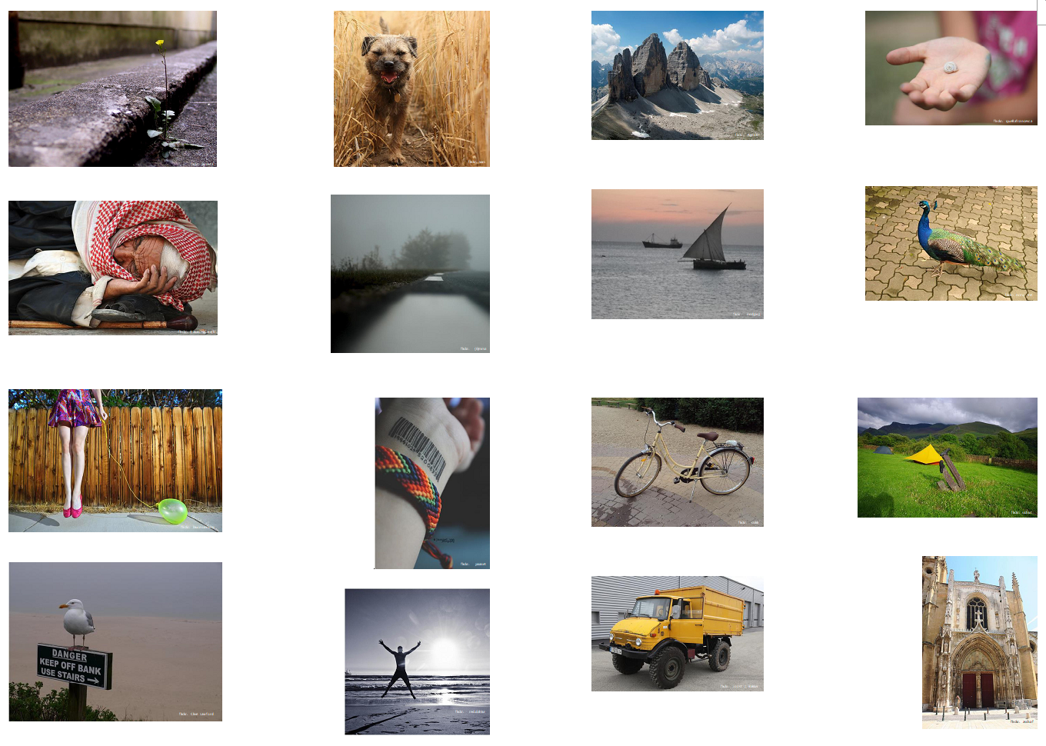
Fig. 1. Some examples used in the exercise “forced<>fit”.

Figure 1 shows some examples of images used in this type of exercise. They were collected from the online photographic platform Flickr in 2024 and are all licensed under Creative Commons license (CC). Their respective authors are marked within the pictures by their Flickr handles.
The exercise called “forced<>fit” was particularly designed to help overcome mental blocks and system standards as well as to stimulate creativity. The exercise consists of mumbling groups (Waldherr et al. 2021) who are given a photograph printed in full colour on a sheet of paper. The first task is to freely collect as many associative strings as possible for the chosen picture, similar to Santamarina (2003), and then discuss it with one to two participants for a short amount of time. Afterwards, their results and insights are shared with the class. The exercise has proven to be easily applicable and yet powerful enough to help participants with problem solving tasks and to experience the benefits of networking with knowledgeable individuals in our experimental setting by fostering creativity.

Workshop Design
The workshop is divided into three phases: onboarding and activation (1), creative co-creation of creativity (2) and summarising the results (3). These are illustrated in figure 2 hereafter. Within the timeframe of 60 minutes, the project-based group work (Melguizo-Garín et al. 2022) takes place and is prospected to valuable results on the workshop’s topic.

Fig. 2. Workshop Design in Three Phases

While the first phase (Onboarding & activation) is dominated by the starting phase, everyone briefly introduces itself (1.1, Welcome & introduction) and the framework of the workshop, it’s goals and working modes are presented to set up the following process. A short introduction into the topic of creativity is given by the trainers (1.2) to have everyone on the same page. The initial phase is scheduled for approximately 10 minutes. It is crucial to establish a productive and welcoming atmosphere for the workshop and to ensure a similar level of knowledge among participants.

The second and main phase of the workshop is consisting of work in small groups of three to eight people, dynamically allocated depending on the number of participants. If attendance is particularly low, the workshop might also be conducted with one larger group only. These groups however are then tasked with discussing and exchanging their perspectives from their corresponding background on creativity in engineering education and profession. A worksheet is prepared to foster and steer this project-based group work as well as to document their efforts at the same time. The group work is introduced by using an exercise to foster creative thinking such as the example “forced<>fit” shown above. This phase is scheduled to take place for 25 minutes.

As third phase, which lasts for 20 minutes and focuses on the exchange of creativity concepts and teaching methods respectively, the findings of each small group will be collected and summarised in front of the entire workshop audience. Each group will briefly present their specific findings (3.1), which will then be collectively discussed by the larger workshop group (3.2). This discussion will be moderated and documented by the workshop trainers. Finally, a summary of the findings will be presented for further discussion (3.3). To conclude the workshop, the results are summarised and put up for discussion (3.3). These results will be published in the revised workshop paper thereafter in the final workshop report.

Expected Results
The workshop aims to provide a platform to discuss creativity in engineering and engineering education from a theoretical as well as practical perspective. This can help to develop new methods and strategies to promote creativity in teaching practices within engineering programmes, thereby enhancing students' ability to think creatively and innovatively.

The workshop aims to provide valuable insights into and exchange on the conceptual framework of creativity in engineering education and its impact on STEM fields. In addition, the workshop aims to engage collaboration and knowledge sharing among educators and researchers. The goal is to gain a deeper understanding of how creativity is perceived within STEM disciplines and its implications for educational practices and career paths. This will help researchers deepen their understanding of engineers' education and career choices (Jeanrenaud AUTHORS 2023).

Acknowledgements
The project, in which this workshop is embedded in, was funded by the German Federal Ministry of Education and Research (BMBF) under the funding code ANONYMISED. The responsibility for the content of this publication lies with the author. The ongoing research project is fully funded under the programme “ANONYMISED”. The project continues from October 2022 until September 2025.

References
Abra, J. 1994. “Collaboration in Creative Work: An Initiative for Investigation.” Creativity Research Journal 7 (1): 1–20. https://doi.org/10.1080/10400419409534505.
Badran, I. 2007. “Enhancing Creativity and Innovation in Engineering Education.” European Journal of Engineering Education 32 (5): 573–85. https://doi.org/10.1080/03043790701433061.
Bedewy, S. E., and Z. Lavicza. 2023. “STEAM + X - Extending the Transdisciplinary of STEAM-Based Educational Approaches: A Theoretical Contribution.” Thinking Skills and Creativity 48:101299. https://doi.org/10.1016/j.tsc.2023.101299.
Ciolacu, M. I., B. Mihailescu, T. Rachbauer, C. Hansen, C. G. Amza, and P. Svasta. 2023. “Fostering Engineering Education 4.0 Paradigm Facing the Pandemic and VUCA World.” Procedia Computer Science 217:177–86. https://doi.org/10.1016/j.procs.2022.12.213.
Conradty, C., and F. X. Bogner. 2018. “From STEM to STEAM: How to Monitor Creativity.” Creativity Research Journal 30 (3): 233–40. https://doi.org/10.1080/10400419.2018.1488195.
Conradty, C., and F. X. Bogner. 2020. “STEAM Teaching Professional Development Works: Effects on Students’ Creativity and Motivation.” Smart Learn. Environ. 7 (1). https://doi.org/10.1186/s40561-020-00132-9.
Conradty, C., S. A. Sotiriou, and F. X. Bogner. 2020. “How Creativity in STEAM Modules Intervenes with Self-Efficacy and Motivation.” Education Sciences 10 (3): 70. https://doi.org/10.3390/educsci10030070.
Cropley, D. H. 2015. “Promoting Creativity and Innovation in Engineering Education.” Psychology of Aesthetics, Creativity, and the Arts 9 (2): 161–71. https://doi.org/10.1037/aca0000008.
Emami, M., S. Rezaei, N. Valaei, and J. Gardener. 2023. “Creativity Mindset as the Organizational Capability: The Role of Creativity-Relevant Processes, Domain-Relevant Skills and Intrinsic Task Motivation.” APJBA 15 (1): 139–60. https://doi.org/10.1108/APJBA-12-2020-0437.
Felder, R. M. 1988. “Creativity in Engineering Education.” Chemical Engineering Education (CEE) 22 (3): 120–25.
Henriksen, D. 2014. “Full STEAM Ahead: Creativity in Excellent STEM Teaching Practices.” steam 1 (2): 1–9. https://doi.org/10.5642/steam.20140102.15.
AUTHORS. 2023. “Digitalisation as an Opportunity for Women in STEM: Researching the Nexus of School, University and Labour Market.” European Society for Engineering Education (SEFI), 2211–21. https://doi.org/10.21427/Z323-BX67.
Kirillov, N. P., E. G. Leontyeva, and Y. A. Moiseenko. 2015. “Creativity in Engineering Education.” Procedia - Social and Behavioral Sciences 166:360–63. https://doi.org/10.1016/j.sbspro.2014.12.537.
Landes, M., E. Steiner, and T. Utz. 2022. “Kreativität Und Innovation in Organisationen.”.
Melguizo-Garín, A., I. Ruiz-Rodríguez, M. A. Peláez-Fernández, J. Salas-Rodríguez, and E. R. Serrano-Ibáñez. 2022. “Relationship Between Group Work Competencies and Satisfaction with Project-Based Learning Among University Students.” Frontiers in psychology 13:811864. https://doi.org/10.3389/fpsyg.2022.811864.
Nordstrom, K., and P. Korpelainen. 2011. “Creativity and Inspiration for Problem Solving in Engineering Education.” Teaching in Higher Education 16 (4): 439–50. https://doi.org/10.1080/13562517.2011.560379.
Pusca, D., and D. Northwood. 2018. “Curiosity, Creativity and Engineering Education.” Global Journal of Engineering Education 20 (3). http://www.wiete.com.au/journals/GJEE/Publish/vol20no3/01-Pusca-D.pdf. Accessed April 07, 2024.
Qadir, J. 2023. “Engineering Education in the Era of ChatGPT: Promise and Pitfalls of Generative AI for Education.” In 2023 IEEE Global Engineering Education Conference (EDUCON), 1–9: IEEE.
Santamarina, J. C. 2003. “Creativity and Engineering: Education Strategies.” In Internatonal Conference on Engineering Education in Honor of James T.P. Yao, 99–107.
Stouffer, B., and J. Russell. 2004. “Making the Strange Familiar: Creativity and the Future of Engineering Education.” In Proceedings, edited by ASEE: ASEE Conferences.
Tiza, D. R. H., E. E. Herrera, J. P. T. Lipa, E. C. Checa, C. J. L. Mamani, F. A. Limo, E. W. P. Paricahua, L. P. Paricahua, and H. Quispe Berrios. 2023. “Promoting Creativity and Innovation Through Agile Engineering in Design Education: Comparative Analysis in Latin America.” Operational Research in Engineering Sciences: Theory and Applications (ORESTA) 6 (1): 410–31. https://doi.org/10.31181/oresta/0601135.
Waldherr, F., C. Walter, J. Wendorff, and M. Kipp. 2021. “Murmelgruppe Oder Buzz Group.” In Didaktisch Und Praktisch: Methoden Und Medien Für Die Präsenz- Und Onlinelehre, edited by F. Waldherr, and C. Walter. 3. überarbeitete und erweiterte Auflage 2021, 50–52. Freiburg: Schäffer-Poeschel Verlag für Wirtschaft Steuern Recht GmbH.
AUTHOR. 2023. “Can Students’ Self-Efficacy Beliefs Explain Academic Motivation and Career Intentions?” European Society for Engineering Education (SEFI), 1471–78. https://doi.org/10.21427/694C-DC64.

Corresponding Author

