All Inclusive

Initials Last name
Affiliation
Town, Country
ORCID
(1 space)
Initials Last name
Affiliation
Town, Country
ORCID
(2 spaces)
Conference Key Areas: Innovative Teaching and Learning Methods, Diversity and Inclusion.
Keywords: Diversity, Inclusive Strategies, Innovative STEM Teacher Training, Reflection, Perspective Dialogue
ABSTRACT
Addressing diversity and inclusion within engineering education is vital for nurturing responsible and innovative engineers capable of tackling societal and environmental challenges. This workshop is aimed at exploring inclusive classroom strategies through playing the game All Inclusive. Drawing from real-life teacher experiences, the game acts as a vehicle for thought, i.e. a conversation starter on how to utilize a diverse student cohort to increase learning potential. The workshop is structured to ensure interactive participation, with an emphasis on small group discussions and plenary sessions to foster collective insight into inclusivity strategies. By the end of the session, participants are expected to gain a deeper understanding of diversity's potential as a resource, develop ideas for inclusive practices and take away a novel, game-based tool for application in their educational contexts.

Introduction
The push for increased diversity and inclusivity throughout the educational system is becoming increasingly recognized, not just as a moral imperative, but also as a practical necessity.

Efforts to enhance diversity and inclusivity within universities aim to create environments, where all students and faculty feel supported and valued, regardless of their backgrounds. This is concerned with ensuring equitable access to resources, fostering a sense of belonging, and promoting a culture that respects and celebrates diversity. Such environments are crucial for driving innovation, enhancing problem-solving, and preparing students for a global workforce. Unlocking the potential of diversity is particularly salient within the engineering education arena, where we aim to educate the responsible, innovative engineers of tomorrow. Engineers who will take social and environmental responsibility in developing and using technologies to solve problems, we do not even know are problems yet (Rattleff and Sass 2023).

This workshop will introduce its’ participants to a game designed with the purpose to explore how teachers can create an inclusive classroom with a diverse student cohort. Rather than an instructional manual, the game should be seen as a vehicle for thought, i.e. a conversation starter on how to utilize a diverse student cohort to increase learning potential.

Motivation and Rationale for this workshop
“The reason I entered my course into the EuroTeQ course catalogue was that I could see how my course could really benefit from the diverse perspectives on how health care options are organised differently, even within seemingly homogenous European countries, but I ended up finding it really difficult to engage and motivate my online exchange students in the learning activities I set up…”
EuroTeQ Teacher

The Technical University of Denmark (DTU) is part of the EuroTeQ Alliance, a strategic academic partnership between predominantly technical universities. In this context we have a shared course catalogue in which teachers from across the alliance can offer their course to students across the alliance. The courses are offered in a purely online or hybrid format, with home students participating in-person, and EuroTeQ students participating online. As educational developers, our role within this partnership has been to support the development of innovative course formats to be offered through this course catalogue. It is in this context that three primary drivers led us to develop this game:

- Feedback from teachers
Diversity comes in many forms, and through our work with consulting and sparring with teachers at DTU, we have experienced that teachers and consultants often lack the tools to engage with the challenges and potentials that such diversity brings to the classroom. Whilst diversity expressed through gender, academic pre-requisites, learning preferences and neurodivergence are areas that most teachers in higher education deal with, the EuroTeQ course format offers a particular view into diversity as expressed through cultural and institutional differences and multimodal participation (e.g. synchronous online/physical participants).

- DTU Learning Lab teaching philosophy to “Teach as you Preach” (Rattleff and Sass 2023)
As responsible for the STEM higher education teacher training at DTU, we wanted to develop an icebreaker activity feeding into a deeper conversation about diversity in all its expressions as according to the feedback we receive from our teachers.

- Sustainability
When visiting, and receiving visits, from partners, we often ended up putting together tote bags with pens, notepads, and various gadgets. We wanted to be able to provide a EuroTeQ relevant, engineering education oriented, and sustainable memorabilia.

We consequently set out to create a tool and conversation starter, that has the potential to contribute to our efforts in flipping diversity from being a challenge to being a resource for students, teachers, and universities alike.

Learning Outcomes
The learning outcome for this workshop is to examine how we as universities can release the potential of diversity.

Together we will
- explore classroom diversity dilemmas and inclusive approaches.
- discuss initiatives at the universities that increase the diversity potential.
- outline a roadmap towards inclusive practices.

Participants will
- reflect on diversity from a teacher and student perspective.
- develop ideas for inclusive practices.

Theoretical Framework
In the pursuit of inclusive teaching within STEM higher education, educators are tasked with developing a classroom environment that actively values and leverages the diversity of its students. Inclusion is seen as the ability of all individuals to contribute fully and effectively within an educational setting. It underscores the importance of fostering an atmosphere where students from all backgrounds feel valued, supported, and empowered to participate actively and meaningfully. (Ahmad 2019)

To achieve this, teachers must integrate a variety of competences into their pedagogical toolkit, including social, communicational, cultural, and psychological skills. These competences are essential for addressing and overcoming the barriers to inclusion, such as bias and stereotyping, lack of representation, discrimination, systemic inequities, cultural insensitivity and inadequate support and mentorship. (Awang-Hasim et al. 2019, Ceo-Difrancesco et al. 2019, Engelbrecht et.al 2013, Kruse et al, 2018, Molbaek 2018, European Commision 2019)

To develop and establish inclusive practices in STEM higher education, we need to consider both the cultivation of inclusive values and skills and approach inclusion from the perspectives of institutions, teachers, and students.

Following this line of thought, this game consists of three primary segments through which the teacher is asked to reflect on different approaches to diversity and inclusivity in the STEM Higher Education classroom: Dilemmas, Competences and Characters.

Dilemmas
The 17 dilemmas selected for this game are based on real life dilemmas experienced by our teachers at DTU. They have been selected to represent the range of diversity that our teachers encounter, not only within EuroTeQ, but perhaps more visible in that context. As such there will be dilemmas related to diversity as expressed though cultural differences, learning preferences, neurodivergence, gender, academic pre-requisites, and participation forms, i.e. online, hybrid or physical.

Competences
Three factors played into the selection of the 17 competences included in this game.

The competences identified in the literature review, as referred to above, provided the first round of narrowing down the scope of potential competences. We then cross-referenced this list with the 21 competences identified through a survey with >300 participants from companies in the EuroTeq universities' ecosystem.
This exploration into the expected competencies of our students shifts the focus of inclusive teaching. It moves beyond merely creating an inclusive learning environment to addressing the question of which inclusive competencies will increase students’ employability.

Finally, we selected 17 competences, that we identified as broad enough to allow individual interpretation for teachers across our alliance, academic disciplines, and individual differences.

Characters
The last part of All Inclusive invites a well-known character into the game, who people can attribute certain characteristics to. We were inspired by the third person perspective dialogue workshop introduced by Hermsen, Dommelen and Espinosa (2023) at the SEFI 2023 conference in TU Dublin. We activate Hermsen, Dommelen and Espinosa’s proposed introduction of a third person perspective in unfolding behavioural insights and inviting reflection, in the context of All Inclusive related to how different behavioural strategies and competencies will produce different outcomes in turning diversity to a resource in various educational settings.

Workshop Setup
To the extent possible, the room will be prepared with tables spread out to allow 4-5 participants at each table. Participants will arrive and place themselves accordingly. One game will be prepared at each table.

The session will commence with a ten-minute presentation of the rationale and motivation for creating the game, an overview of the theoretical underpinnings and the selection of a “game master” at each table.

All Inclusive, the game
Following the introduction and overview, the participants will be given five minutes to go over the rules of the game and then 15-20 minutes to play the game. The facilitators will be available for questions and clarifications throughout the game.

The game design and rules are as follows:
Setup: Participants arrange the dilemma, competence, and character cards into three separate piles, face down. The gamemaster reveals the top card from the dilemma pile, then shuffle the competence cards and deal 3 to each player.

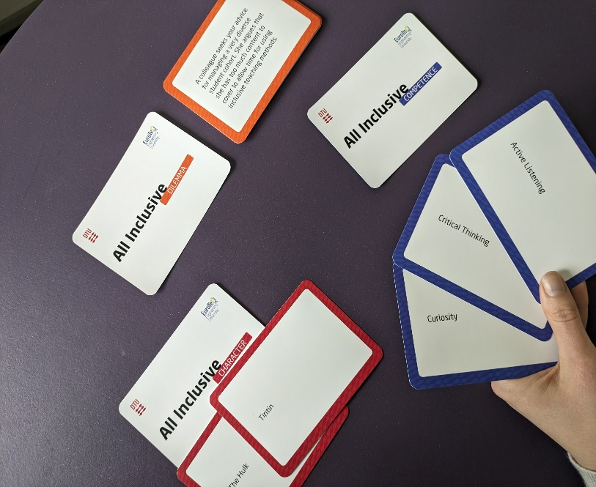
Dilemma Discussion: Gamemaster reads the dilemma card out loud. Players discuss the dilemma, acknowledging that players may interpret it differently.
Competence Reveal: Each player selects one competence card and discuss its’ relevance in addressing the dilemma.
Character Perspective 1: Gamemaster reveals a character card. Players discuss how the character might approach the dilemma.
Character Perspective 2: Gamemaster reveals another character card. Explore how this new character might approach the dilemma in a different way than the previous character.
Reflection and Takeaways: Each player shares their insights from the discussion, focusing on how they would engage with similar dilemmas in the future.

Collect reflections and feedback
We will explore classroom diversity dilemmas and inclusive approaches, playing “All Inclusive”. We will debate initiatives that increase the diversity potential.
Based on this we will outline a roadmap on what actions the institution can initiate, what instructors can do, and what competencies we would like to offer our students the opportunity to develop.

To allow all participants equal opportunity to contribute, we will run the session following the think-pair-share approach. Discussions will occur in both small groups and larger, plenary sessions. Insights will be documented on note sheets or captured digitally, to be compiled at the workshop's conclusion and presented as outlined in fig. 1.

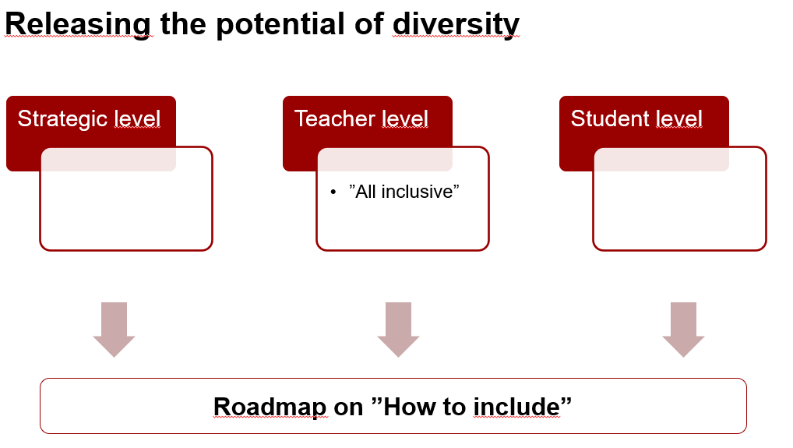
Fig. 1 Compilation of ideas developed during the workshop

Take home messages
Participants gain personal insights as they reflect on diversity from a teacher and student perspective, develop ideas for inclusive practices and take home a practical, game-based tool to use at their respective institutions.

Further take-aways to be added after the workshop in accordance with road map (fig. 1).

REFERENCES
Ahmad, A. S., Sabat, I., Trump-Steele, R., King E. “Evidence-Based Strategies for Improving Diversity and Inclusion in Undergraduate Research Labs.” Frontiers in Psychology 10 (2019). https://doi.org/10.3389/fpsyg.2019.01305
Awang-Hashim, R., Kaur, A., and Valdez, N. P. "Strategizing Inclusivity in Teaching Diverse Learners in Higher Education." Malaysian Journal of Learning and Instruction 16, no. 1 (2019): 105-128. https://doi.org/10.32890/mjli2019.16.1.5
Ceo-Difrancesco, D., Kochlefl, M. K., Walker, J. "Fostering Inclusive Teaching: A Systemic Approach to Develop Faculty Competencies." Journal of Higher Education Theory and Practice 19, no. 1 (2019): 31-43.
Engelbrecht, P. (2013). Teacher education for inclusion, international perspectives. European Journal of Special Needs Education, 28(2), 115–118. https://doi-org.proxy.findit.cvt.dk/10.1080/08856257.2013.778110
European Commission, Directorate-General for Education, Youth, Sport and Culture, Key competences for lifelong learning, Publications Office, 2019, https://data.europa.eu/doi/10.2766/569540
Hermsen, P., Van Dommelen, S., & Hueso Espinosa, P. (2023). Reflection On Your Personal Perspective Through Other Perspectives. A Step In Dealing With Wicked Problems. European Society for Engineering Education (SEFI). https://doi.org/10.21427/GFTG-HQ42
“Ideate the EuroTeQ Professionals” EuroTeQ. Access date: 05.04.2024 https://euroteq.eurotech-universities.eu/docuwiki/wp4/
Kruse, S. D., Rakha, S., & Calderone, S. (2018). Developing cultural competency in higher education: an agenda for practice. Teaching in Higher Education, 23(6), 733–750. https://doi-org.proxy.findit.cvt.dk/10.1080/13562517.2017.1414790
Molbaek, M. Inclusive teaching strategies – dimensions and agendas. International Journal of Inclusive Education, 22(10) (2018): 1048–1061. https://doi-org.proxy.findit.cvt.dk/10.1080/13603116.2017.1414578
Rattleff, P., & Sass, D. S. "Teach as You Preach: Teacher Training For STEM-Educators At DTU." European Society for Engineering Education (SEFI) (2023). https://doi.org/10.21427/6BZA-7C58.

Corresponding Author (All in Arial, 10 pt, single space) Intials Last name e-mail address
https://euroteq.eurotech-universities.eu/docuwiki/wp4/

