ARCHIMEDEAN OATH: A REFLECTION TOOL FOR RESPONSIBLE ENGINEERS

Initials Last name
Affiliation
Town, Country
ORCID
Initials Last name
Affiliation
Town, Country
ORCID
Conference Key Areas: Teaching the knowledge, skills and attitudes of sustainable engineering (1), Engineering ethics in education (12)
Keywords: Responsible engineers, critical thinking, Archimedean Oath, Ethics, Sustainability
ABSTRACT
This workshop, inspired by the Archimedean Oath, seeks to engage participants in critically reflecting on the responsibilities of engineers in society. Following the update of the content of the Oath to address contemporary challenges, the workshop aims at fostering ethical considerations among graduate students, educators, and industry professionals. Through a partially immersive experiences and thematic discussions, participants will explore various representations of the Oath and its implications for engineers who adopt it and more broadly, for the engineering practice. The workshop will provide a platform to discuss diverse perspectives, allowing attendees to understand the Oath's fundamental principles and its potential as a tool for ethical reflection. Emphasizing the importance of ethical decision-making in complex and rapidly changing environments, the proposed activities seek to use the Archimedean Oath as a tool to empower engineers to uphold principles of social responsibility and environmental stewardship, while acknowledging the need for a more scaffolded integration of ethics and sustainability throughout the engineering curriculum. By the end of this interactive workshop, participants will have gained insights into the significance of the Archimedean Oath, identified strategies for incorporating it into educational settings, and critically analysed the pertinence of the Oath as a reflection tool. The workshop will therefore provide a valuable opportunity for stakeholders to engage with the ethical dimensions of engineering and contribute to the development of practices fostering responsible engineering.

outline

Motivation and Learning outcomes:
Inspired by the Archimedean Oath, written at [institution] in 1990, and recently updated by a student-led effort, this workshop aims at leveraging the Oath as a tool to trigger reflection. Participants will explore multiple illustrations of the Oath and discuss the various strategies to foster active and meaningful engagement with the ideas expressed in the Oath, as opposed to oaths being passive pledges. We see the Oath as an instrument to prompt engineers to reflect on their calling to responsible engineers, and an opportunity to look back at what they have learned in their study programme through the lenses of ethics and sustainability.
To prompt critical and constructive considerations about the roles of engineers in our society, stakeholders from industry, heads of institutions, teachers and students are invited to participate in this partially immersive experience.
At the end of the workshop participants will:
- Explain the Archimedean Oath to a larger and diverse audience, including its fundamental principles, intentions, and scope.
- Be able to raise awareness about the multiple affordances of the Archimedean Oath as a tool to trigger ethical reflections on the role responsible engineers should have in our current and future society.
- Have a holistic opinion on how the oath can be perceived from the perspective of educators, learners, curriculum developers, institutions and hiring professionals.
- Reflect on the utility value of the tool itself.
This workshop will be most useful for:
- Graduate students.
- Teachers interested in and/or teaching topics related to ethics, sustainability, and value-led education.
- University administrators in charge of university policies.
- Professionals who see the need for hiring engineers capable of taking ethical and sustainability challenges into account in their daily work.

Background and rationale
In the increasingly complex, interconnected and rapidly changing world, scientists, researchers, and engineers often face ethical dilemmas and moral complexities in their work within and outside academia (Shamoo et Resnik 2009). Additionally, because of the rapidly changing effects of climate change on the environment and our societies, engineers need to use their expertise to design rapidly evolving solutions (The Lemelson Foundation 2022).
Technical and engineering education institutions are increasingly focusing on nurturing students' critical thinking skills, particularly with regards to ethics and sustainability, confirming the relevance of the broader responsibilities of engineering students in addressing complex global challenges (authors, 2022; Lozano et al. 2013). For this reason, we expect students to commit to and, most importantly, reflect on the ethical consequences of their work.
In other fields, the coupling between ethical concerns and science has been perhaps more evident. In medicine, graduating doctors adopt the Hippocratic Oath. Composed over 2,400 years ago, and originally written for physicians, is the most ancient and well known example of explicit integration of ethics in professional practice (Hulkower 2016). In ecology and environmental sciences, the publication of Rachel Carson’s Silent Spring warned the public about the dangers of pesticides to society and eventually contributed to the beginning of the environmental movement (Shamoo et Resnik 2009). More recently, the growing complexity of information systems, urge software engineers to make an increasing number of decisions involving ethical components (Järvinen 2017).
In 1990, inspired by the Hippocratic Oath, a group of four physics students from [institution], gathered for the first time to write an oath for engineers: the Archimedean Oath. Their aim was to make an active contribution to the development of their institution and highlight their awareness of their responsibility to the positive development of the world. That year, the Oath was signed by approximately 40% of the students during their graduation ceremony before falling into disuse. Since then, the Oath has been adopted at the discretion of the faculty dean. Similarly to the Hippocratic Oath (Hulkower 2016), it has lost some of its relevance due to its outdated nature and therefore students do not easily identify with its principles. For this reason, a student association at [institution] updated the text, allowing students to better identify themselves with contemporary challenges.
The Archimedean Oath prioritizes the well-being of all and the preservation of the environment in professional practice (Figure 1). It emphasizes personal responsibility, ongoing improvement, and consideration of wider consequences on a larger scale. It cautions against military applications and commits to environmental and social preservation, equity, justice, transparent communication, and integrity.

While conceptually significant, the Archimedean Oath has not been extensively studied or discussed in academic literature compared to the more established ethical frameworks in science. We also acknowledge the limitations of an Oath requiring engineers to commit to ethical and sustainability principles for which they might not have been trained throughout their whole engineering curriculum. Nonetheless, we trust that the Archimedean Oath has the potential to trigger a reflection on ethical and sustainability aspects of the engineering profession, create a sense of belonging and empowerment, and increase accountability and responsibility in graduating engineers.

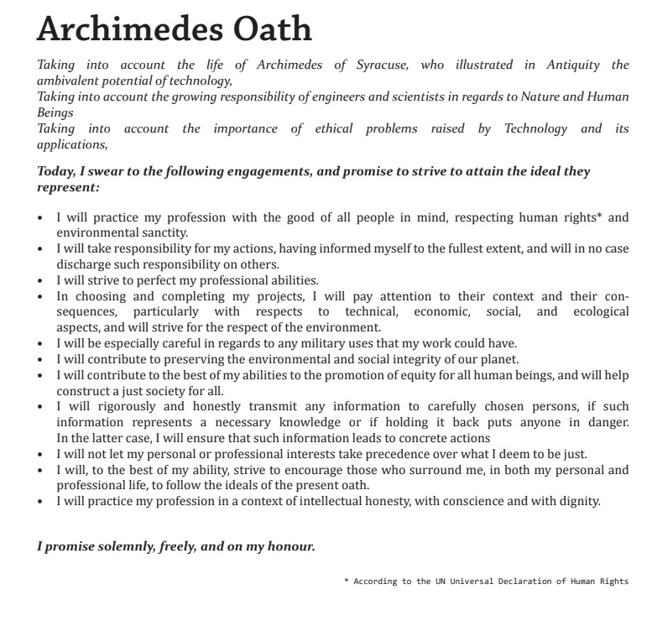
Figure 1: Archimedean Oath (last updated 2023)

structure of the workshop

Workshop plan
This workshop is part of a larger project that aims at providing higher education institutions with a tool, the Archimedean Oath, that prompts engineers to reflect on their responsibilities to society and nature during and upon the end of their studies.
Table 1: Workshop plan
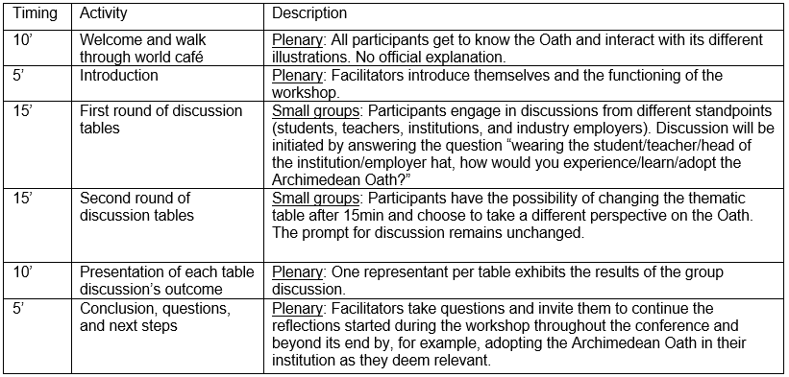

Expected Outcome
The expected outcomes of this workshop are the increased adoption of the Archimedean Oath, and the enhanced engagement with it (in education, as a reflection tool) by all concerned. To increase its relevance across contexts, we will be collecting suggestions on how to best adapt the Oath to diverse institutional, societal, and cultural contexts in which it can be potentially used. To facilitate immediate adoption, we will provide participants with the Archimedean Oath so that they continue the reflections in their institutions and raise awareness about the importance of this tool in engineers’ responsible practices.
In the final report of the workshop, we will provide salient points raised during the discussions, highlight the advantages and limitations of the tool and present strategies to interact with it in different institutional and cultural contexts. As mentioned above, participants will be also invited to continue their engagement by participating on the working group aimed at the operationalisation of the Oath as a tool for reflection and accountability to responsible engineers.

REFERENCES
Hulkower, Raphael. 2016. « The history of the Hippocratic Oath: outdated, inauthentic, and yet still relevant ». Einstein Journal of Biology and Medicine 25 (1): 41‑44.
Järvinen, H.M. 2017. « Ethics as a Skill of a Software Engineer? » In Conference Proceedings of SEFI 2017, edited by J.C Quadrado, J Bernardino, et J Rocha, 7. Azores, Portugal: European Society for Engineering Education SEFI. http://urn.fi/URN:NBN:fi:tty-201711292280.
Lozano, Rodrigo, Rebeka Lukman, Francisco J. Lozano, Donald Huisingh, et Wim Lambrechts. 2013. « Declarations for Sustainability in Higher Education: Becoming Better Leaders, through Addressing the University System ». Journal of Cleaner Production 48 (juin): 10‑19. https://doi.org/10.1016/j.jclepro.2011.10.006.
Shamoo, Adil E, et David B Resnik. Responsible conduct of research. Oxford University Press. 2009.
The Lemelson Foundation. 2022. « The Engineering for One Planet Framework: Essential Sustainability-focused Learning Outcomes for Engineering Education ». Portland, Oregon, USA. https://engineeringforoneplanet.org/wp-content/uploads/EOP_Framework_2023.pdf.
Authors. 2022. In 9th Research in Engineering Education Symposium (REES 2021) and 32nd Australasian Association for Engineering Education Conference (REES AAEE 2021)

Corresponding Author (All in Arial, 10 pt, single space) Intials Last name e-mail address

