Dance like there’s no one watching: evolution of the upper Darling River (Bourke to Wilcannia), New South Wales, Australia

Gresley A Wakelin-King 1,2

1 Wakelin Associates Pty Ltd, Melbourne, Vic., Australia

2 Latrobe University, School of Agriculture, Biomedicine and Environment; Bundoora, Vic., Australia

* **This abstract is for an Oral**
* **Session: Palaeoclimate, Tectonics and Glaciation**

# ABSTRACT

A reach-to-regional desktop study was undertaken of the fluvial corridor of the upper Darling River (Barkindji country), north-western NSW. Historically home to many indigenous groups, the area experienced intense use during colonial expansion of pastoralism. In the present day, erosion repair is a common land management goal, but rehabilitation design is hampered by poor documentation of riverine processes. The client brief was to interpret the fluvial landscape, with reference to 2022 floods. Methods: collation and manipulation of spatial data, and integration of existing geological resources with new floodplain mapping.

On the ground, the Darling feels like a low-intensity and semi-static landscape. The sparsely-vegetated floodplains are low-relief expanses of dusty grey cracking-clay soils, crossed by shallow swales, flood runners, and channel segments. The main channel is actively meandering with a highly sinuous planform, but everything is on a small scale (c.f. the Murray River): both channel and channel belt (scroll plains) are narrow and occupy only a fraction of the fluvial corridor’s width.

At a regional scale it can be seen that the Darling River has been responding to neotectonic and climatic influences with a vigorous program of ongoing personal reinvention. Tectonic influences range from a crustal-scale shear zone, to intersecting sets of N-S, NNE-SSW and ENE-WSW faults, with shear, subsidence, and uplift effects. The consequences range from subcatchment-scale drainage network geometry to reach-scale channel planform and dune distribution.

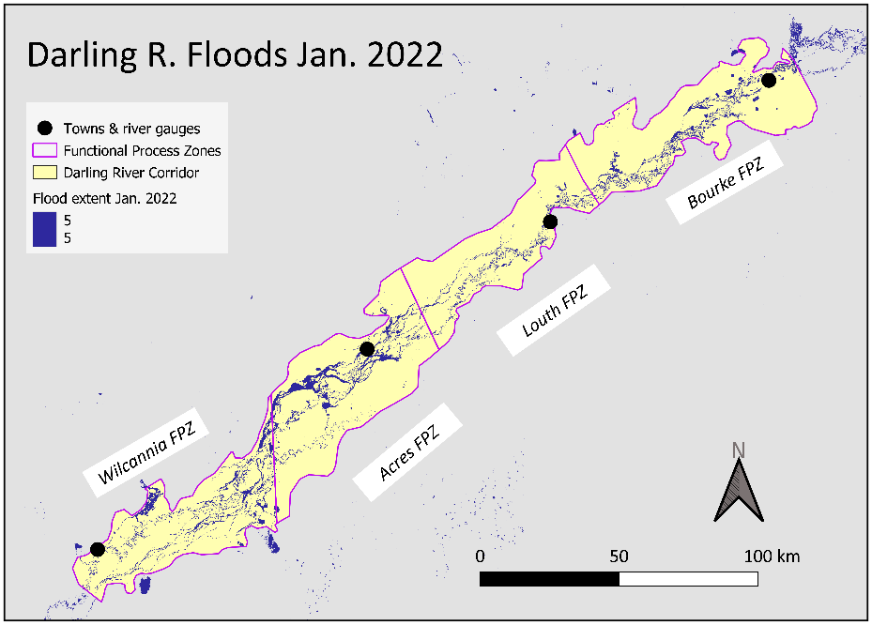Previous fluvial iterations are visible in a rich variety of floodplain landforms. Wetter palaeoclimates created the broad scale of the ancestral Darling, and the bedload capacity that made the silty levees that flank prior streams (c.f. the present-day main channel). Through avulsion, some of the prior streams are now quasi-anabranches of the main channel, including the Darling River’s “Sliding Doors moment” where the present-day N-S main channel overprints the E-W prior stream.

Client-relevant results: new functional process zones (FPZ) based on floodplain geomorphology, a data-driven structured enquiry process (the Darling Assessment Tool) to identify repair opportunities, flood footprint maps showing floodplain-level flow paths that are independent of the main channel and bypass the river gauges, and a report summary via StoryMaps (https://arcg.is/1j8Xyu).